Lir NOTF ORE Industry Access Programme
Application for the Testing of Marine Renewable Energy Devices and Technologies CALL REMAINS OPEN UNTIL 17th June 2022
Contact Lir NOTF facility manager when preparing application.

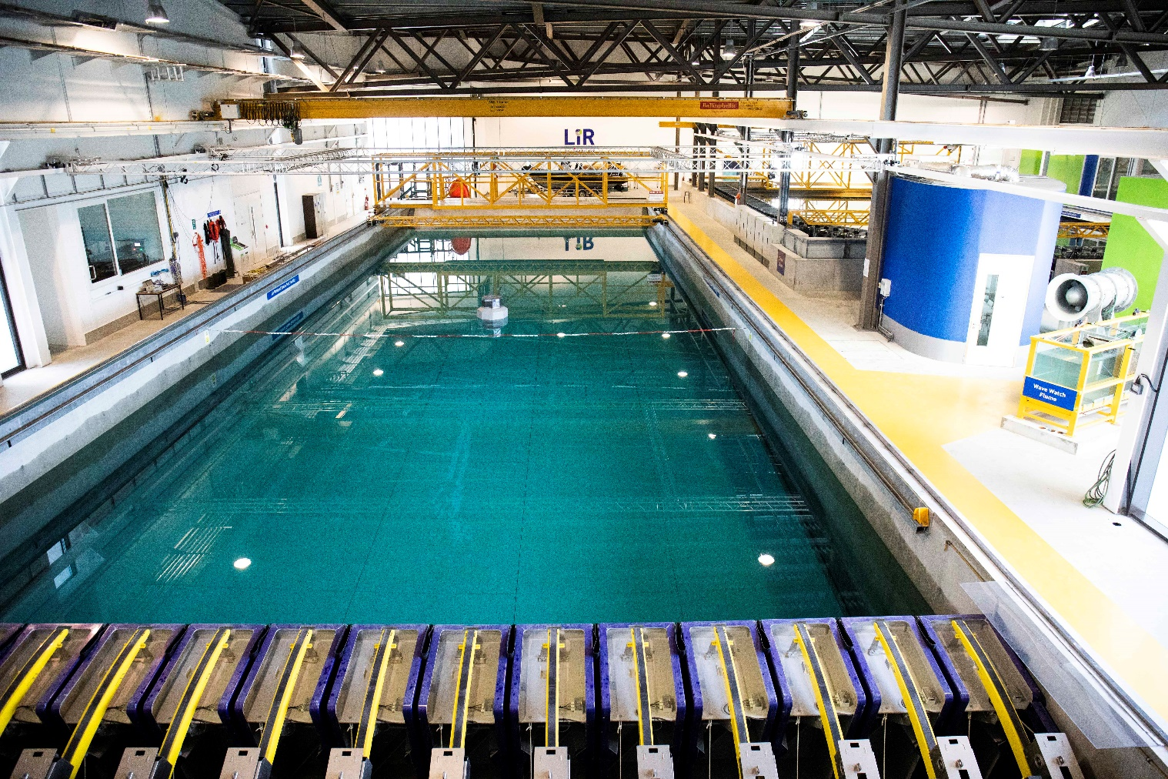

Deep Ocean Basin at Lir-NOTF

Completed application forms should be returned to ianpower@ucc.ie with all necessary documentation before 17th June 2022

Introduction
The Lir-National Ocean Test Facility (Lir NOTF) is Ireland’s primary facility for testing and development of offshore technologies and has a long track record in supporting offshore renewable energy (ORE) technologies through early stage TRL development. While fixed offshore wind technologies are commercially advanced, many offshore renewable energy (ORE) technologies that are required for deeper water and more aggressive environments are still in early stages of development. These technology developers usually consist of individuals, SMEs and academics who generally do not have the financial resources and expertise to determine the feasibility of their concept and require support. As a result, SEAI and Lir NOTF have teamed up to offer this programme which will provide free to access the to the facilities of Lir-NOTF to Irish ORE developers.
This access programme to the Lir-NOTF is designed to enable the testing and progression of ORE technologies through the early development stages in advance of open sea testing. It is supported by SEAI and is open to any type of ORE technology (wave, wind, tidal, floating solar) that can be tested at the Lir NOTF.
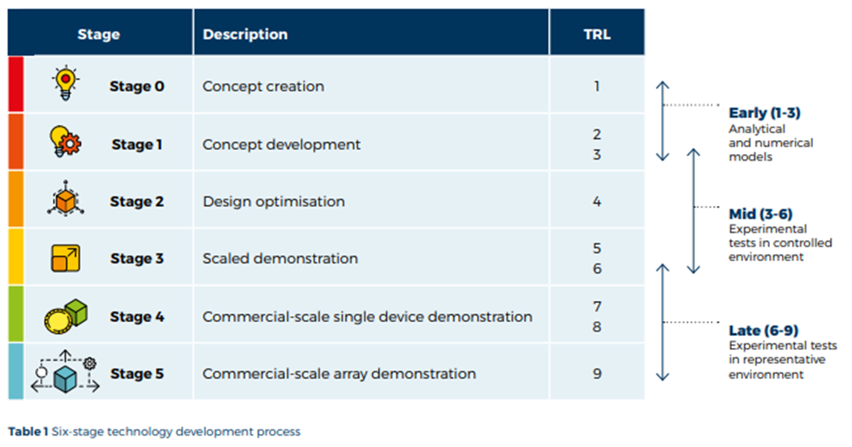
Therefore, applications are invited for the testing of ORE concepts that can show efficient operations and survivability in Irish ORE sites and also can ultimately be beneficial to the Irish economy. These applications will be assessed by a Selection Panel (SP) comprising of experts in this sector.
Successful applicants will have access to one of the following facilities or equivalent use of equipment;
- Deep Ocean Basin
- Ocean Basin
- Wave and Current Flume
- Wave Watch Flume
- El Electrical laboratory / Energy laboratory
In this access programme the applicant will be expected to supply the model and possibly some of the instrumentation for testing. The Lir NOTF staff will check, setup and run all the tests and on completion will provide all the test data to the applicant.
Please note the following
- Applicants are required to contact the test facility to discuss proposed plans prior to applying
- The maximum access that will be granted is two weeks of tank testing
- All testing must be completed by end December 2022 with feedback submitted withen two weeks post testing.

More information can be found at (www.lir-notf.com) or by emailing ianpower@ucc.ie.
Please read the Application Guidelines before applying.

Group Details
Project Leader details (enclose a curriculum vitae also)
Title
Family name
First name
Gender
Birth year
Nationality
Country where appl. Works
Phone
Email
Company name
Company acronym
Position in Company
Company postal address
Company country
Company web address
Please also include details for all other members of the group (if any) as above.

Group Details
Other Team Member details (enclose a curriculum vitae also)
Title
Family name
First name
Gender
Birth year
Nationality
Country where appl. Works
Phone
Email
Company name
Company acronym
Position in Company
Company postal address
Company country
Company web address

Access Details
Research infrastructure for which you are applying for access (see above list);
Is this your only application in this call? | Yes / No
If No, please give details: (approx. 100 words)

Length of time required for testing
Suggested start date
Details of any major timing constraints when you will be unable to test within the testing period (July-December 2022) (100 words approx.)

History
Selection and eligibility
New user: have you ever used (for research purposes) the proposed Research Infrastructure before? | Yes / No
If Yes, please give details: (approx. 100 words)

Description
Brief summary of the proposed work (approx. 100 words)
Do you have a model already fabricated or have you the capacity to do so? Give details (approx. 100 words)
Please attach up to two images of the device being submitted for testing. Images must be in JPEG or PNG format only. Videos of model outlining the working principle can also be submitted.

Introduction - include background, scientific/technical context of the tests (if previously tested, please
give brief details of the most recent test location/facility, dates and result achieved in relation to design requirements). (approx. 300 words)

Intellectual Property –is the technology patented? Discuss capacity to share data/knowledge arising from the testing (approx. 100 words)

Project objectives - including potential commercial benefits/progress. (approx. 100 words) Please see Application Guideline for Intellectual Property arrangement.

Potential impacts of proposed testing (scientific, commercial, environmental) (approx. 100 words)

Outline test plan and timeline (approx. 300 words) - include proposed plan of work and timing. It is important that the scope of work be very well focused with clearly defined primary and secondary objectives. Include full timings (for setup, calibration, testing, removal etc.) Please contact the facility you hope to test at before commencing with this section. Contact details are in the Application Guidelines.

Analysis (approx. 100 words) - Please briefly outline your plans for the proposed analysis of the results following access.

If previous tests have been carried out, please include the summary description of the most recent results here: (approx. 300 words)

Specific requirements (approx. 300 words) - include details of tentative equipment/instrumentation/materials required (subject to what is offered by the infrastructure - see infrastructure description), technical assistance and training required etc.:

Relevance and potential benefits to Ireland
Indicate technology development strategy and commercialisation pathway and how it will help meet Irelands energy objectives and benefit the Irish supply chain. (approx. 300 words)

